Guide for PE_Sample_01

1. Question 1 (Windows Forms Application):

## Create a new windows forms project named Question1:

by clicking File, New, Project, Windows, Windows Forms Application, then type “Question1” as below

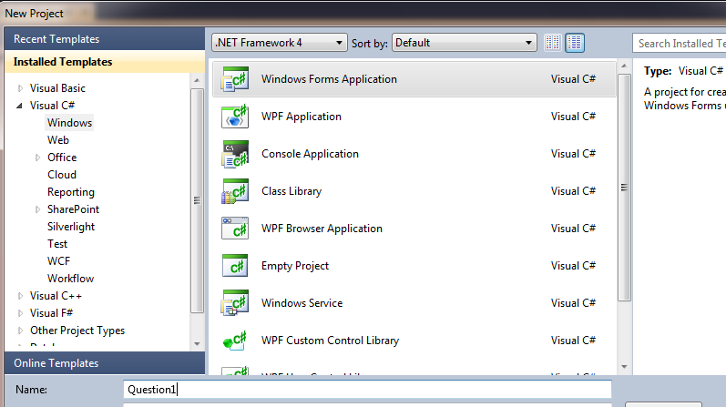

## Open Form1, add the following controls as below

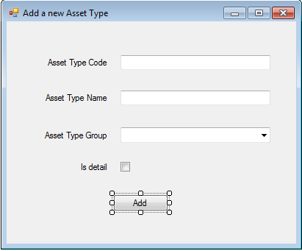

btnAdd

chkIsDetail

cboAssetTypeGroupID

txtAssetTypeName

txtAssetTypeCode

Methods handle events:

public partial class Form1 : Form

{

string strConn = @"server=localhost; database=CNET_PE;Integrated security=true";

public Form1()

{

InitializeComponent();

// lay du lieu tu bang AssetTypeGroups ve DataSet

SqlConnection conn = new SqlConnection(strConn);

SqlDataAdapter da = new SqlDataAdapter("select * from AssetTypeGroups order by GroupName", conn);

DataSet ds = new DataSet();

da.Fill(ds);

// gan du lieu cho cboAssetTypeGroupID

cboAssetTypeGroupID.DataSource = ds.Tables[0];

cboAssetTypeGroupID.DisplayMember = "GroupName";

cboAssetTypeGroupID.ValueMember = "AssetTypeGroupID";

}

private void btnAdd_Click(object sender, EventArgs e)

{

if (txtAssetTypeCode.Text == "")

{

MessageBox.Show("Please enter Asset Type Code");

return;

}

if (txtAssetTypeName.Text == "")

{

MessageBox.Show("Please enter Asset Type Name");

return;

}

//Add a new Asset type into Database

SqlConnection conn = new SqlConnection(strConn);

SqlCommand cmd = new SqlCommand("Insert into AssetTypes(AssetTypeCode, AssetTypeName, AssetTypeGroupID, IsDetail)" +

" Values(@AssetTypeCode, @AssetTypeName, @AssetTypeGroupID, @IsDetail)", conn);

cmd.Parameters.AddWithValue("@AssetTypeCode", txtAssetTypeCode.Text);

cmd.Parameters.AddWithValue("@AssetTypeName", txtAssetTypeName.Text);

cmd.Parameters.AddWithValue("@AssetTypeGroupID", int.Parse(cboAssetTypeGroupID.SelectedValue.ToString()));

cmd.Parameters.AddWithValue("@IsDetail", chkIsDetail.Checked?1:0);

conn.Open();

cmd.ExecuteNonQuery();

conn.Close();

string info = "";

info += "A new Asset Type is added!\n";

info += "\nAsset Type Code:" + txtAssetTypeCode.Text;

info += "\nAsset Type Name:" + txtAssetTypeName.Text;

info += "\nAsset Type GroupID:" + cboAssetTypeGroupID.Text;

info += "\n" + (chkIsDetail.Checked? "Is not detail" :"Isdetail");

MessageBox.Show(info, "Information Dialog");

}

}

1. Question 2 (Web Application):

## Create a new web project named Question2:

by clicking File, New, Project, Web, ASP.NET Empty Web Application, then type “Question2” as below 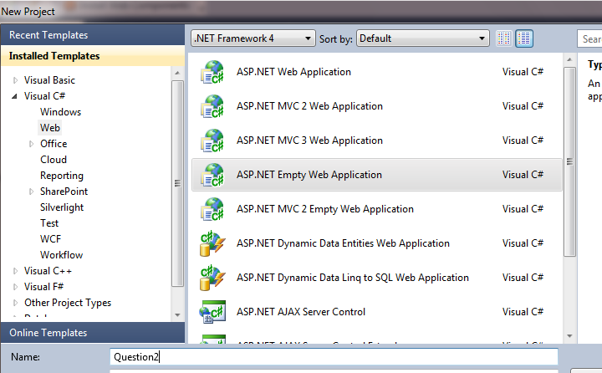

## Add a new page named SearchProducts.aspx:

by pointing to Project name, right clicking to display context menu, then click Add, New Item, Web, Web Form, then type “SearchProducts.aspx”. Open this page, then add the following controls as below

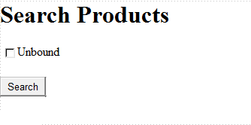

btnSave

CheckBoxList1

Methods handle events

public partial class SearchProducts : System.Web.UI.Page

{

static string strConn = "Server = localhost; Database = CNET_PE; Integrated Security = true";

protected void Page_Load(object sender, EventArgs e)

{

if (!IsPostBack)

{

// Lay du lieu ve DataSet

SqlConnection conn = new SqlConnection(strConn);

SqlDataAdapter da = new SqlDataAdapter("select * from categories", conn);

DataSet ds = new DataSet();

da.Fill(ds);

//Gan cho CheckBoxeList

CheckBoxList1.DataSource = ds.Tables[0];

CheckBoxList1.DataTextField = "CategoryName";

CheckBoxList1.DataValueField = "CategoryID";

CheckBoxList1.DataBind();

}

}

protected void btnSearch_Click(object sender, EventArgs e)

{

string filter = "";

foreach (ListItem item in CheckBoxList1.Items)

{

if (item.Selected)

if (filter == "")

filter = "Products.CategoryID = "+ item.Value.ToString();

else

filter += " OR Products.CategoryID = " + item.Value.ToString();

}

Session["filter"] = filter;

Response.Redirect("SearchResults.aspx");

}

}

## Add a new page named SearchResults.aspx

by pointing to Project name, right clicking to display context menu, then click Add, New Item, Web, Web Form, then type “SearchResults.aspx”. Open this page, then add the following controls as below

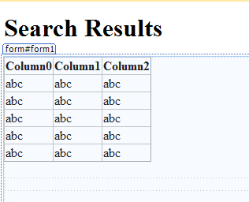

GridView1

Methods handle events

public partial class SearchResults : System.Web.UI.Page

{

string strConn = @"Server = localhost\SQLEXPRESS; Database = CNET_PE; Integrated Security = true";

protected void Page_Load(object sender, EventArgs e)

{

if (!IsPostBack)

{

SqlConnection conn = new SqlConnection(strConn);

string filter;

if (Session["filter"] != null)

filter = (string) Session["filter"];

else filter = "";

if (filter != "") filter = " AND (" + filter + ")";

SqlDataAdapter da = new SqlDataAdapter("select ProductName, CategoryName as Category, QuantityPerUnit, UnitPrice, UnitsInStock from products, categories " +

"where categories.categoryID = products.categoryID" + filter, conn);

DataSet ds = new DataSet();

da.Fill(ds);

GridView1.DataSource = ds.Tables[0];

GridView1.DataBind();

}

}

}